Task 1: - Draw a labelled diagram of a typical home Wi-Fi setup showing a modem, router, switch, access point, and at least two devices (like a laptop and smartphone) connected to the network.
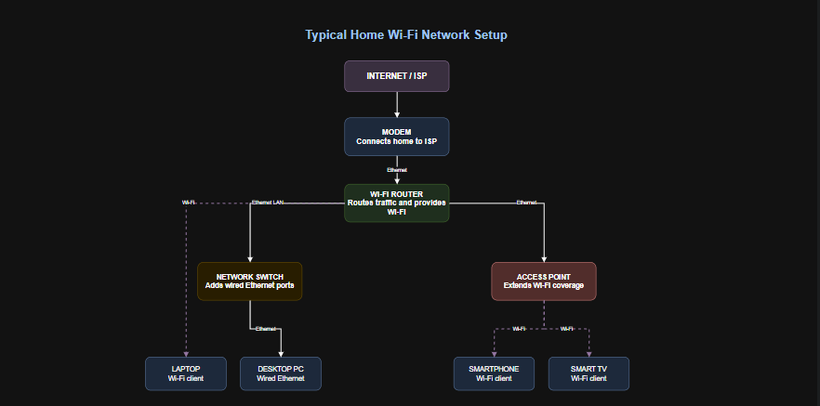
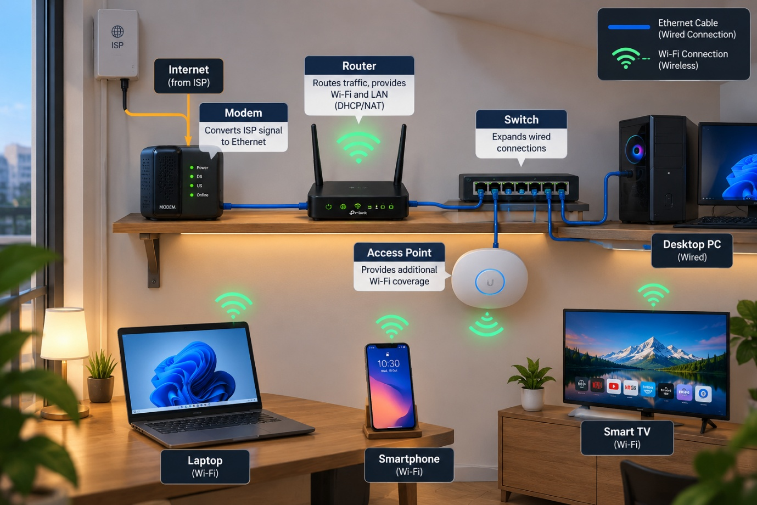

Task 2: - List the main function of each networking hardware device: modem, router, switch, access point, and network cable. For each, give a real-life example of where you might see or use it (for example, 'router: at home to share internet').

No. | Networking Device | Main Function | Real-Life Example
1 | Modem | Connects a network to the internet service provider (ISP) by converting communication signals. | Used at home to receive a broadband internet connection.
2 | Router | Routes data between networks and shares internet access among devices. | Used at home to connect smartphones and laptops to the internet.
3 | Switch | Connects multiple wired devices within a local area network (LAN). | Used in an office to connect computers and printers.
4 | Access Point | Provides wireless connectivity to devices through Wi-Fi. | Used in a college to provide Wi-Fi in classrooms.
5 | Network Cable | Transmits data between devices through a wired connection. | Used to connect a desktop PC to a router using an Ethernet cable.
6 | Network Interface Card (NIC) | Enables a computer to connect to a network through Ethernet or Wi-Fi. | Used in a laptop to connect to a wireless network.
7 | Repeater | Regenerates or retransmits signals to extend network coverage. | Used to extend Wi-Fi coverage to another room.
8 | Bridge | Connects two LAN segments and filters traffic between them. | Used to connect two sections of a small office network.
9 | Firewall | Monitors and filters network traffic according to security rules. | Used in a company to block unauthorized network access.
10 | Gateway | Connects networks that may use different protocols or communication systems. | Used in an organization to connect its internal network to an external network.

Task 3: - Take photos or find images online (with source links) of at least three types of network cables (such as Ethernet, coaxial, fiber optic) and write one line describing where each is commonly used.
Three Types of Network Cables
1. Ethernet Cable (Twisted Pair)
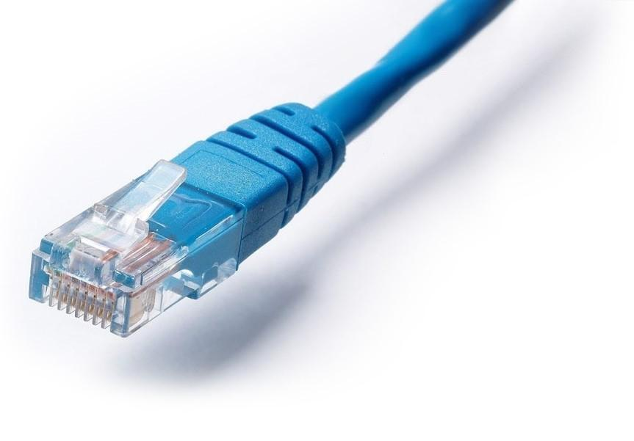
Common use: Connects computers, routers, switches, and other network devices in homes, schools, and offices.

2. Coaxial Cable
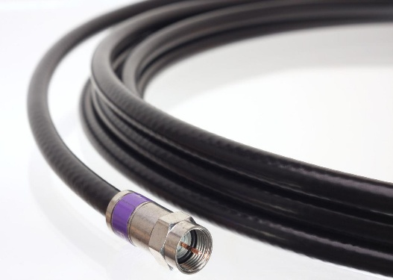
Common use: Carries cable television, satellite signals, and some broadband internet connections.

3. Fiber-Optic Cable
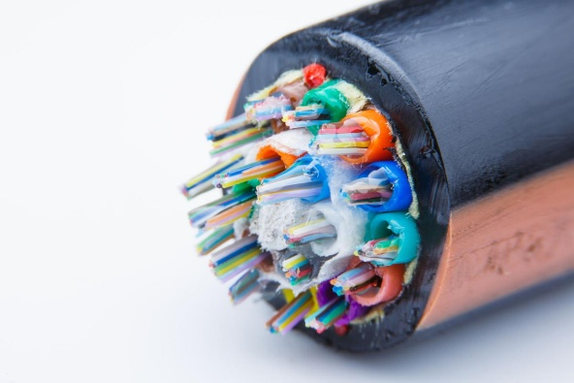
Common use: Transmits data as light signals at high speeds over long distances, such as in internet backbones and fiber-to-the-home connections.

Task 4: - Create a comparison table listing at least four differences between a router and a switch, including their main use, typical location, and how they handle data.

No. | Basis | Router | Switch
1 | Main Use | Connects different networks and shares internet access. | Connects multiple devices within the same local area network (LAN).
2 | Typical Location | Commonly found in homes, offices, and internet gateways. | Commonly found in offices, computer labs, and data centers.
3 | How It Handles Data | Forwards data packets between networks using IP addresses. | Forwards Ethernet frames within a LAN using MAC addresses.
4 | OSI Model Layer | Primarily operates at Layer 3 (Network Layer). | Typically operates at Layer 2 (Data Link Layer).
5 | Internet Connectivity | Commonly connects a local network to the internet. | Usually connects local devices; it does not independently provide internet access.
6 | Broadcast Domains | Separates broadcast domains between routed interfaces. | A standard Layer 2 switch forwards broadcasts within the same VLAN.
7 | Wireless Support | Many home routers include built-in Wi-Fi. | Most switches provide wired connections only.
8 | Example | A home router connects smartphones and laptops to the internet. | An office switch connects desktop computers and printers.

